PARKER WSC

Public Water Supply ID: TX1260021

Consumer Confidence Report

2025 CCR

The following pages comprise the Annual Consumer Confidence Report (CCR) for your water system.

Important Information!
In order to meet all the requirements of the CCR, you must include the following additional information if it pertains to your water system.

* The report must include the telephone number of the owner, operator, or designee of the community water system as a source of additional information concerning the report.
* In communities with a large proportion of non-English speaking residents, as determined by the Primacy Agency, the report must contain information in the appropriate language(s) regarding the importance of the report or contains a telephone number or address where such residents may contact the system to obtain a translated copy of the report and/or assistance in the appropriate language.
* The report must include information about opportunities for public participation in decisions that may affect the quality of the water (e.g., time and place of regularly scheduled board meetings).
* Include the location of source water (name of the lake, river, reservoir and/or City, County) in the Source table (page 1). If your water system purchases water from another source, you are required to include the current CCR year's Regulated Contaminants Detected table from your source water supply.
* If your water system had any violations during the current CCR Calendar year, you are required to include an explanation of the corrective action taken by the water system.
* If your water system is going to use the CCR to deliver a Public Notification, you must include the full public notice and return a copy with the CCR. This is in addition to the copy and certification form required by the CCR Rule.
* The information about likely sources of contamination provided in the CCR is generic. Specific information regarding contaminants may be
available in sanitary surveys and source water assessments and should be used when available to the operator. If a source water assessment has been completed for the water system, indicate if a report is available in the Source table (page 1).
* If a community water system distributes water to its customers from multiple hydraulically independent distribution systems fed by different raw water sources, the table should contain a separate column for each service area, and the report should identify each separate distribution system. Alternatively, systems may produce separate reports tailored to include data for each service area.
* Detections of unregulated contaminants for which monitoring is required are not included in the CCR and must be added. When added, the information must include the average and range at which the contaminant was detected.
* If a water system has performed any monitoring for Cryptosporidium, including monitoring performed to satisfy the requirements of the Information Collection Rule [ICR] (141.143), which indicates that Cryptosporidium may be present in the source water or the finished water, the report must include: (a) a summary of the results of the monitoring; and (b) an explanation of the significance of the results.
* If a water system has performed any monitoring for radon which indicate that radon may be present in the finished water, the report must include: (a) The results of the monitoring; and (b) An explanation of the significance of the results.
* If a water system has performed additional monitoring which indicates the presence of other contaminants in the finished water, EPA strongly encourages systems to report any results which may indicate a health concern. To determine if results may indicate a health concern, EPA recommends that systems find out if EPA has proposed an NPDWR or issued a health advisory for that contaminant by calling the Safe Drinking Water Hotline (800-426-4791). EPA considers detects above a proposed MCL or health advisory level to indicate possible health concerns. For such contaminants, EPA recommends that the report include: (a) the results of the monitoring; and (b) an explanation of the significance of the results noting the existence of a health advisory or a proposed regulation.
* If you are a groundwater system that receives notice from a state of a significant deficiency, you must inform your customers in your CCR report of any significant deficiencies that are not corrected by December 31 of the year covered by it. The CCR must include the following information:
- The nature of the significant deficiency and the date it was identified by the state.
- If the significant deficiency was not corrected by the end of the calendar year, include information regarding the State-approved plan and schedule for correction, including interim measures, progress to date, and any interim measures completed.
- If the significant deficiency was corrected by the end of the calendar year, include information regarding how the deficiency was corrected and the date it was corrected.

Note:
These first pages are only instructions and are not part of your CCR. The pages that follow and are numbered in the upper right-hand corner are the report pages.

Annual Drinking Water Quality Report

PARKER WSC

Public Water System ID: TX1260021

We are pleased to present to you the Annual Water Quality Report (Consumer Confidence Report) for the year, for the period of January 1 to December 31, 2025. This report is intended to provide you with important information about your drinking water and the efforts made by the water system to provide safe drinking water. (Este informe contiene información muy importante sobre su agua potable. Tradúzcalo o hable con alguien que lo entienda bien).

For more information regarding this report, contact:

Name: Joe Young

Phone: 817-373-2666

Sources of Drinking Water
PARKER WSC is Purchased surface water.

Our water source(s) and source water assessment information are listed below:

Source Name |  | Type of Water | Report Status | Location
1 - PS 1 / CR 304 | PS 1 | Ground water |  | Johnson County
2 - PS 2 / CR 1200 | PS 2 | Ground water |  | Johnson County
3 - PS 3 / CR 1200 | PS 3 | Ground water |  | Johnson County
SW FROM FILES VALLEY | CC FROM TX1090035 FILES VALLEY WSC | Surface water |  | Hill county

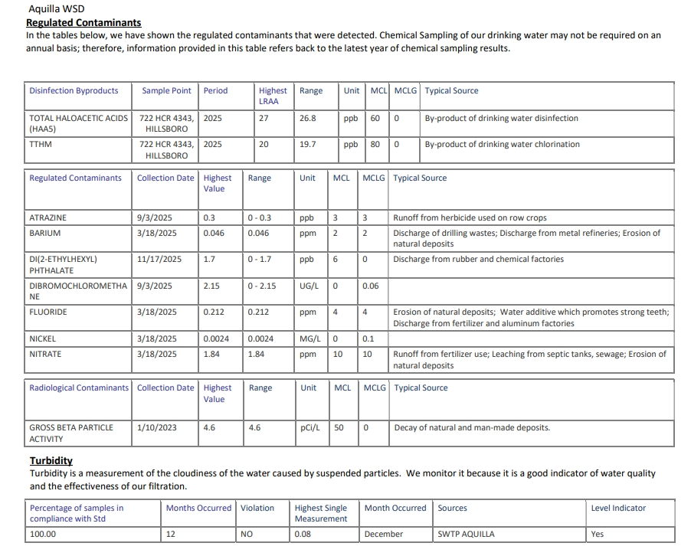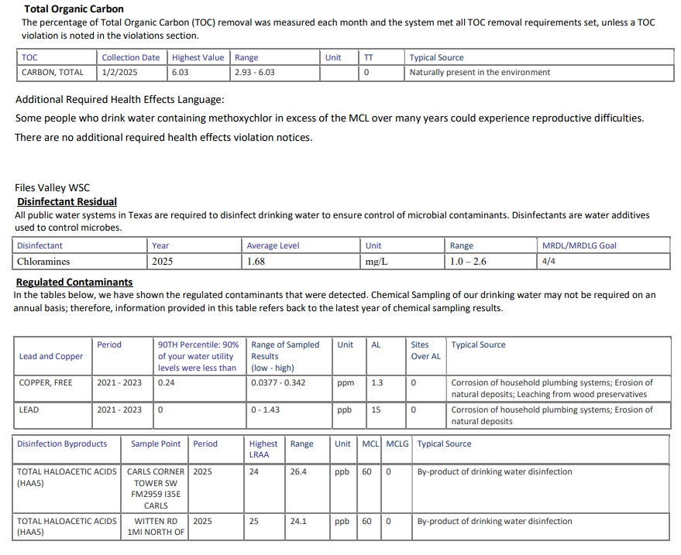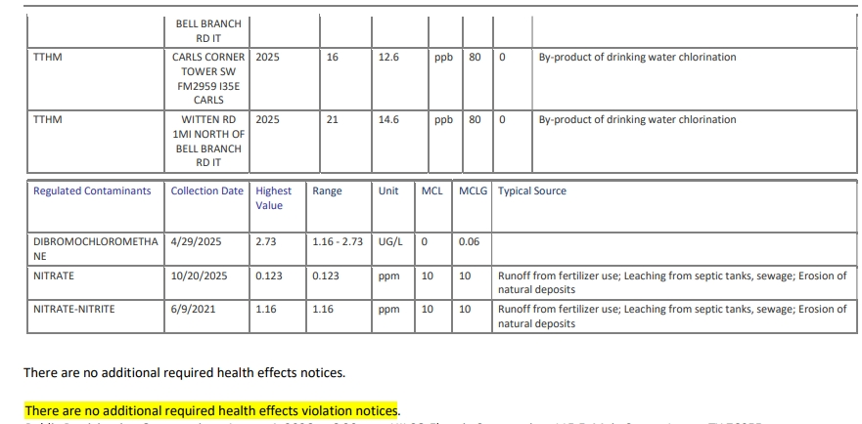

The sources of drinking water (both tap water and bottled water) include rivers, lakes, streams, ponds, reservoirs, springs, and wells. As water travels over the surface of land or through the ground, it dissolves naturally-occurring minerals and, in some cases, radioactive material, and can pick up substances resulting from the presence of animals or from human activity.

Drinking water, including bottled water, may reasonably be expected to contain at least small amounts of some contaminants. The presence of contaminants does not necessarily indicate that water poses a health risk. More information about contaminants and potential health effects can be obtained by calling the EPAs Safe Drinking Water Hotline at (800) 426-4791. Contaminants that may be present in source water include:

A service line inventory has been prepared and can be accessed by calling the office or coming in to office.

Microbial Contaminants - such as viruses and bacteria, which may come from sewage treatment plants, septic systems, agricultural livestock operations, and wildlife.
Inorganic Contaminants - such as salts and metals, which can be naturally-occurring or result from urban stormwater runoff, industrial, or domestic wastewater discharges, oil and gas production, mining, or farming.
Pesticides and Herbicides - which may come from a variety of sources such as agriculture, urban stormwater runoff, and residential uses.
Organic Chemical Contaminants – including synthetic and volatile organic chemicals, which are by-products of industrial processes and petroleum production, and can also come from gas stations, urban stormwater runoff, and septic systems.
Radioactive Contaminants – which can be naturally-occurring or be the result of oil and gas production and mining activities.

In order to ensure that tap water is safe to drink, EPA prescribes regulations which limit the amount of certain contaminants in water provided by public water systems. FDA regulations establish limits for contaminants in bottled water which must provide the same protection for public health.

Some people may be more vulnerable to contaminants in drinking water than the general population.
Contaminants may be found in drinking water that may cause taste, color, or odor problems. These types of problems are not necessarily causes for health concerns. For more information on taste, odor, or color of drinking water, please contact the system's business office.

Immuno-compromised persons such as persons with cancer undergoing chemotherapy, persons who have undergone organ transplants, people with HIV/AIDS or other immune system disorders, some elderly and infants can be particularly at risk from infections. These people should seek advice about drinking water from their health care providers. EPA/CDC guidelines on appropriate means to lessen the risk of infection by Cryptosporidium and other microbial contaminants are available from the Safe Drinking Water Hotline (800-426-4791).

Lead can cause serious health effects in people of all ages, especially pregnant people, infants (both formula-fed and breastfed), and young children. Lead in drinking water is primarily from materials and parts used in service lines and in home plumbing. PARKER WSC is responsible for providing high quality drinking water and removing lead pipes but cannot control the variety of materials used in the plumbing in your home. Because lead levels may vary over time, lead exposure is possible even when your tap sampling results do not detect lead at one point in time. You can help protect yourself and your family by identifying and removing lead materials within your home plumbing and taking steps to reduce your family's risk. Using a filter, certified by an American National Standards Institute accredited certifier to reduce lead, is effective in reducing lead exposures. Follow the instructions provided with the filter to ensure the filter is used properly. Use only cold water for drinking, cooking, and making baby formula. Boiling water does not remove lead from water. Before using tap water for drinking, cooking, or making baby formula, flush your pipes for several minutes. You can do this by running your tap, taking a shower, doing laundry or a load of dishes. If you have a lead service line or galvanized requiring replacement service line, you may need to flush your pipes for a longer period. If you are concerned about lead in your water and wish to have your water tested, contact PARKER WSC at 817-373-2666. Information on lead in drinking water, testing methods, and steps you can take to minimize exposure is available at https://www.epa.gov/safewater/lead.

In the tables below, you will find many terms and abbreviations you might not be familiar with. To help you better understand these terms, we’ve provided the following definitions:

Action Level (AL): The concentration of a contaminant which, if exceeded, triggers treatment or other requirements which a water system must follow.
Action Level Goal (ALG): The level of a contaminant in drinking water below which there is no known or expected risk to health. ALGs allow for a margin of safety.
Level 1 Assessment: A Level 1 assessment is a study of the water system to identify potential problems and determine (if possible) why total coliform bacteria have been found in our water system.
Level 2 Assessment: A Level 2 assessment is a very detailed study of the water system to identify potential problems and determine (if possible) why an E. coli MCL violation has occurred and/or why total coliform bacteria have been found in our water system on multiple occasions.
Maximum Contaminant Level or MCL: The highest level of a contaminant that is allowed in drinking water. MCLs are set as close to the MCLGs as feasible using the best available treatment technology.
Maximum Contaminant Level Goal or MCLG: The level of a contaminant in drinking water below which there is no known or expected risk to health. MCLGs allow for a margin of safety.
Maximum residual disinfectant level goal or MRDLG: The level of a drinking water disinfectant below which there is no known or expected risk to health. MRDLGs do not reflect the benefits of the use of disinfectants to control microbial contaminants.
Maximum residual disinfectant level or MRDL: The highest level of a disinfectant allowed in drinking water. There is convincing evidence that addition of a disinfectant is necessary for control of microbial contaminants.
Treatment Technique or TT: A required process intended to reduce the level of a contaminant in drinking water.
Variances and Exemptions: State or EPA permission not to meet an MCL or a treatment technique under certain conditions.

Avg: Average - Regulatory compliance with some MCLs are based on running annual average of monthly samples.
RAA: Running Annual Average.
LRAA: Locational Running Annual Average.
mrem: millirems per year (a measure of radiation absorbed by the body).
ppb: micrograms per liter (ug/L) or parts per billion - or one ounce in 7,350,000 gallons of water.
ppm: milligrams per liter (mg/L) or parts per million - or one ounce in 7,350 gallons of water.
picocuries per liter (pCi/L): picocuries per liter is a measure of the radioactivity in water.
na: not applicable.

Disinfectant Residual
All public water systems in Texas are required to disinfect drinking water to ensure control of microbial contaminants. Disinfectants are water additives used to control microbes.

Disinfectant | Year | Average Level | Unit | Range | MRDL/MRDLG Goal
Chloramines | 2025 | 1.88 | Mg/L | 0.93 – 2.83 | 4/4

Regulated Contaminants
In the tables below, we have shown the regulated contaminants that were detected. Chemical Sampling of our drinking water may not be required on an annual basis; therefore, information provided in this table refers back to the latest year of chemical sampling results.

Lead and Copper | Period | 90TH Percentile: 90% of your water utility levels were less than | Range of Sampled Results  (low - high) | Unit | AL | Sites Over AL | Typical Source
COPPER, FREE | 2022 - 2024 | 0.114 | 0.0258 - 0.226 | ppm | 1.3 | 0 | Corrosion of household plumbing systems; Erosion of natural deposits; Leaching from wood preservatives
LEAD | 2022 - 2024 | 2.29 | 0 - 4.52 | ppb | 15 | 0 | Corrosion of household plumbing systems; Erosion of natural deposits

Disinfection Byproducts | Sample Point | Period | Highest LRAA | Range | Unit | MCL | MCLG | Typical Source
TOTAL HALOACETIC ACIDS (HAA5) | 11326 SH 171, CLEBURNE | 2025 | 25 | 12.9 | ppb | 60 | 0 | By-product of drinking water disinfection
TTHM | 3201 FM 916, CLEBURNE | 2025 | 17 | 15.7 | ppb | 80 | 0 | By-product of drinking water chlorination

Regulated Contaminants | Collection Date | Highest Value | Range | Unit | MCL | MCLG | Typical Source
ATRAZINE | 7/2/2025 | 0.2 | 0 - 0.2 | ppb | 3 | 3 | Runoff from herbicide used on row crops
BARIUM | 4/28/2025 | 0.053 | 0.05 - 0.053 | ppm | 2 | 2 | Discharge of drilling wastes; Discharge from metal refineries; Erosion of natural deposits
CHROMIUM | 1/7/2025 | 2.7 | 0 - 2.7 | ppb | 100 | 100 | Discharge from steel and pulp mills; Erosion of natural deposits
DIBROMOCHLOROMETHANE | 10/6/2025 | 3.37 | 1.25 - 3.37 | UG/L | 0 | 0.06
FLUORIDE | 1/11/2023 | 0.449 | 0.402 - 0.449 | ppm | 4 | 4 | Erosion of natural deposits; Water additive which promotes strong teeth; Discharge from fertilizer and aluminum factories
NICKEL | 4/28/2025 | 0.0013 | 0 - 0.0013 | MG/L | 0 | 0.1
NITRATE | 4/28/2025 | 0.834 | 0.0704 - 0.834 | ppm | 10 | 10 | Runoff from fertilizer use; Leaching from septic tanks, sewage; Erosion of natural deposits
NITRATE-NITRITE | 5/4/2021 | 0.506 | 0.151 - 0.506 | ppm | 10 | 10 | Runoff from fertilizer use; Leaching from septic tanks, sewage; Erosion of natural deposits
NITRITE | 5/4/2021 | 0.226 | 0 - 0.226 | ppm | 1 | 1 | Runoff from fertilizer use; Leaching from septic tanks, sewage; Erosion of natural deposits

Radiological Contaminants | Collection Date | Highest Value | Range | Unit | MCL | MCLG | Typical Source
COMBINED RADIUM (-226 & -228) | 3/1/2021 | 1.5 | 1.5 | pCi/L | 5 | 0 | Erosion of natural deposits

Additional Required Health Effects Language:
Some people who drink water containing methoxychlor in excess of the MCL over many years could experience reproductive difficulties.

There are no additional required health effects violation notices.

